Git web-hook practical

>>Create one repo -1>>add index.html into repo

URL-https://github.com/Suraj25-tr/repos--1.git

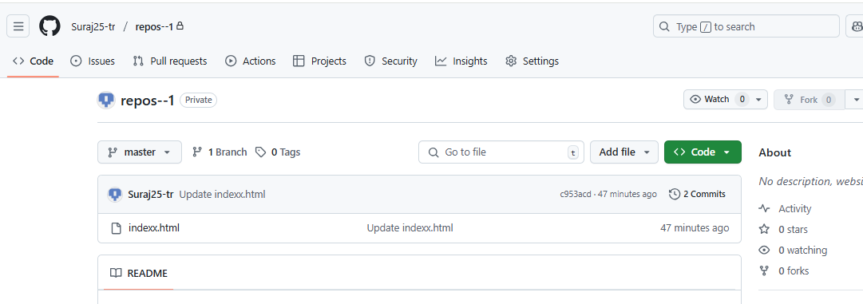

>>Create second repo-2>>add index.html

URL- https://github.com/Suraj25-tr/Repos-2.git

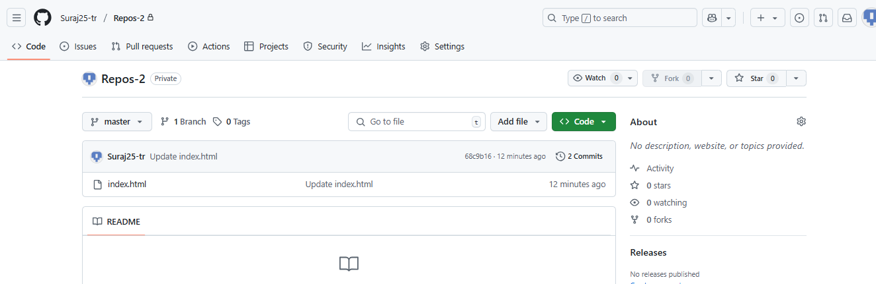

>>Create second repo-3>>add index.html

https://github.com/Suraj25-tr/repos-3.git

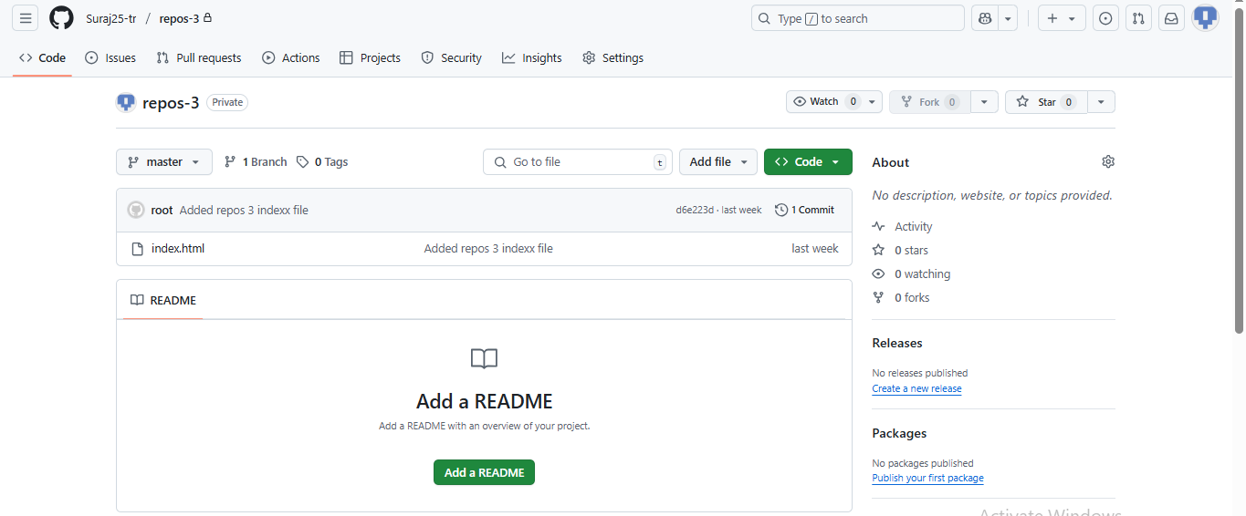

Create Jenkins job

>configure git into it for repo -1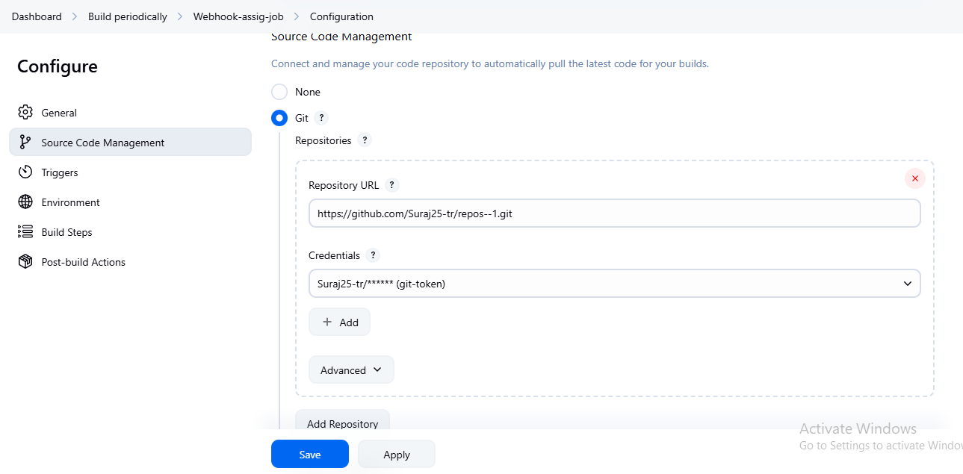

Execute the shell script

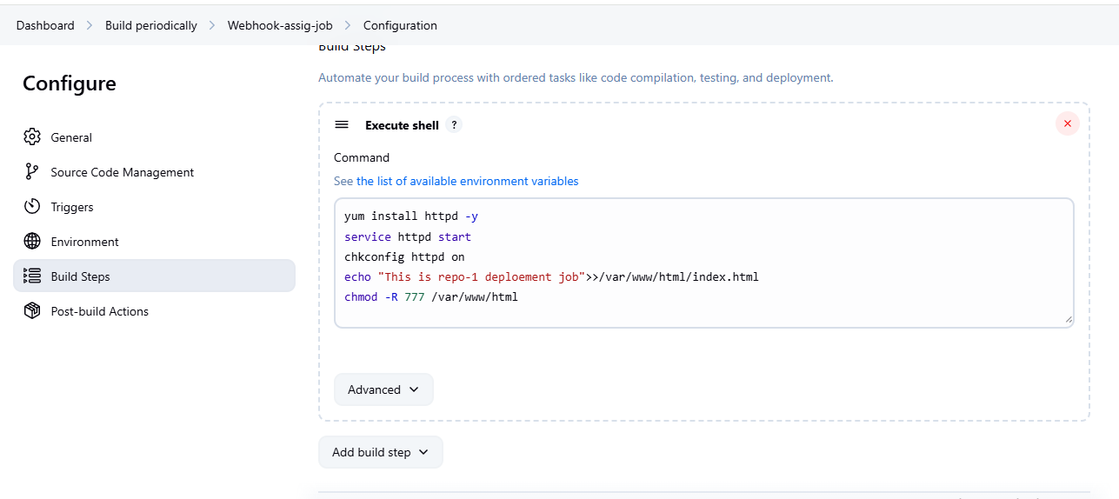

>Do the changes in repo job is triggered automatically

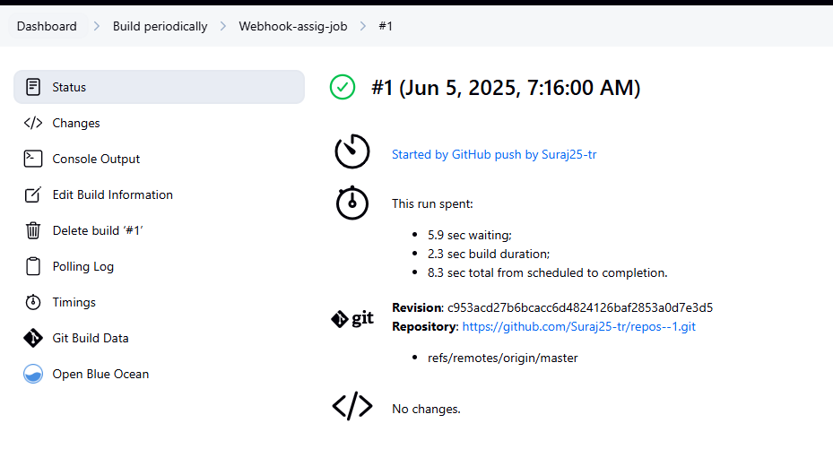

>>create second job add repo

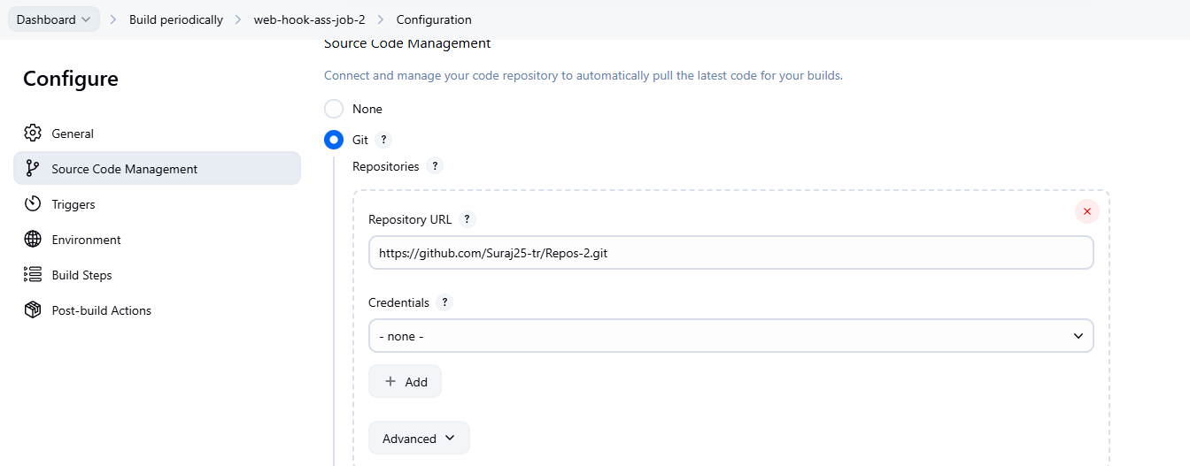

Execute the shell

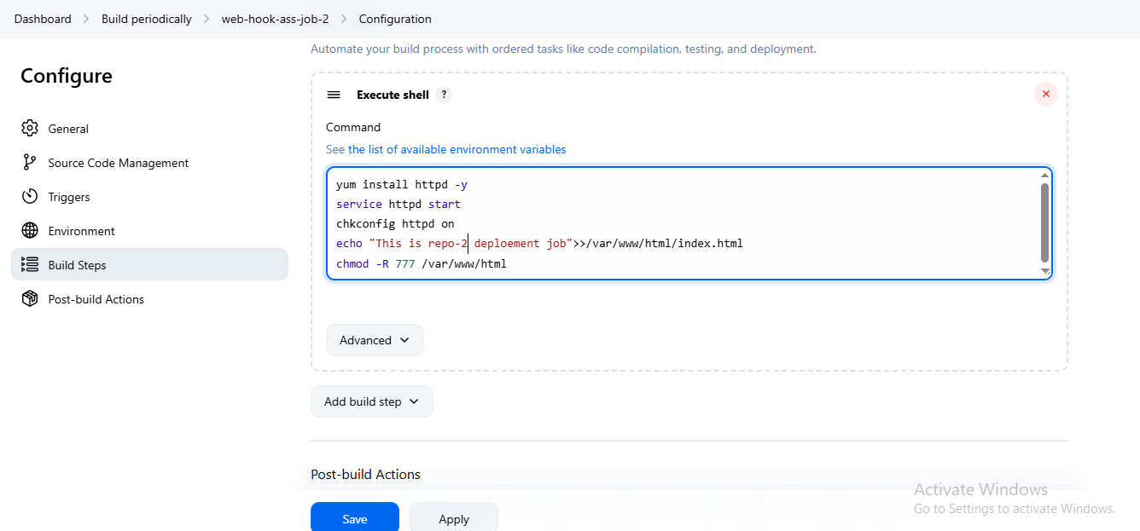

>do changes and job is run automatically deploy index.html

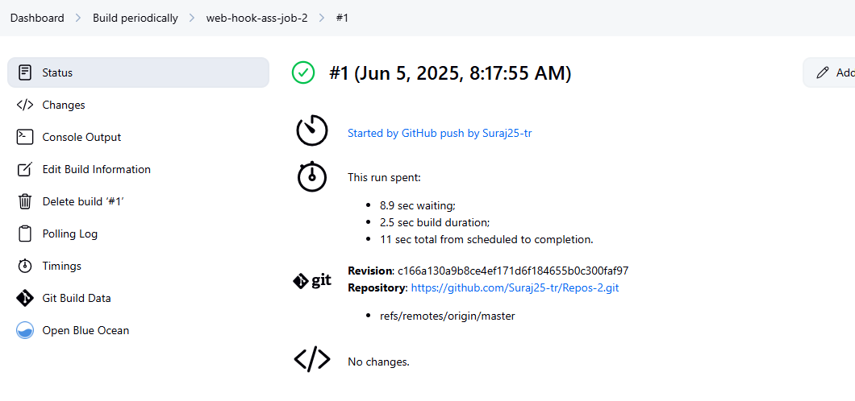

Create job 3 –do the changes and run the job-3

